Student
Name: ………………………………….
Level 1
Ascentis Progression
Unit R/505/6389
Design Software
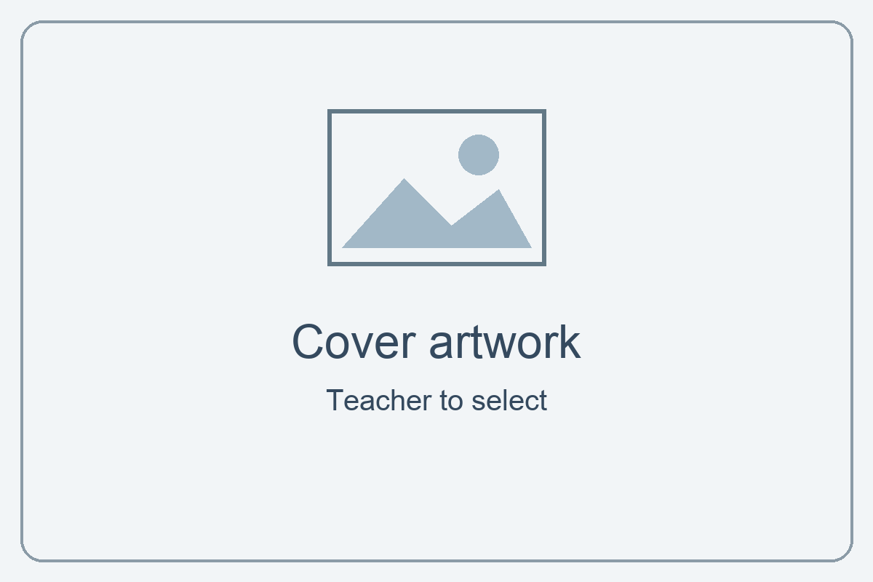

Issue Date | Hand in Date | IV Date | Teacher Name

Learning Outcomes and Assessment Criteria
In order to pass this unit, the evidence that the learner presents for assessment needs to demonstrate that they can meet all the learning outcomes for the unit. The assessment criteria determine the standard required to achieve the unit.
Learning Outcome (The learner will:) | Assessment Criteria (The learner can:)
1. Be able to obtain, insert and combine information for designs. | 1.1 Identify what designs are needed.  1.2 Obtain, input and prepare designs to meet requirements.  1.3 Identify the main copyright and other constraints which apply to the use of designs.  1.4 Combine information of two different types or from two different sources for designs.  1.5 Identify how the designs will be used.  1.6 Identify which file format to use for saving and exchanging designs.  1.7 Store and retrieve files appropriately, in line with local guidelines and conventions where available.
2. Be able to use design software tools to create, manipulate and edit designs. | 2.1 Use suitable tools and techniques to create designs.  2.2 Use appropriate tools and techniques to manipulate and edit designs.  2.3 Check designs meet requirements, using IT tools and making corrections as necessary.

Your project: Design a canteen app
Unit R/505/6389 · Level 1 · 3 credits

Your aim
Collect information, create and edit a design for an audience, then check and improve it.

Your brief
Make a canteen ordering app with your own menu and visual design. It is a classroom simulation: no real orders or payments are sent.

Include in your project
- At least 10 researched items: 4 mains, 3 snacks/desserts, 3 drinks; at least 3 healthy choices across the menu.
- Descriptions, prices, local images, health/allergen information and sources.
- An audience, mood board and labelled wireframe.
- Your own layout, text and style choices, including a direct CSS edit.
- A JavaScript activity attempt and a short learning record.
- Checks, useful corrections, organised files and Git checkpoints.
You can use supplied working functions. You do not need to finish every programming challenge or the optional discount to evidence the unit criteria.

Start and get help
Start with Guide 1 for setup and planning, then Guide 2 and Guide 3. Use the Save/test guide for checking and hand-in.
Open the project hub for the starter, Diner and Riot Bites examples, and all four guides. The guides teach the skills. This booklet records your evidence. Use short notes and clear screenshots. Your teacher can record a demonstration where appropriate.

Task 1: What does your design need?
Assessment criterion: 1.1. Use Guide 1, Step 1.
Explore the starter. Choose your audience and eight needed features. Think about browsing, choosing, reading and checking an order.
Who will use my app?

No. | Feature / visual element
1
2
3
4
5
6
7
8

Two choices and why they matter
Pick two features from your list. Explain how they help your audience.

Task 2: Where will it be used?
Assessment criterion: 1.5. Use Guide 1, Step 1.
Device and place
Choose a device and place, such as a tablet at a canteen counter.

Design choice 1 and how it helps

Design choice 2 and how it helps

Task 3: Menu research — Mains
Assessment criterion: 1.2. Use Guide 1, Step 2.
Include at least three healthy choices across the full menu. Record source pages or packaging references. You can add extra records if needed.

Item 1
Name / short description | Price / healthy? / allergens
Source(s) for food information and price:

Item 2
Name / short description | Price / healthy? / allergens
Source(s) for food information and price:

Item 3
Name / short description | Price / healthy? / allergens
Source(s) for food information and price:

Item 4
Name / short description | Price / healthy? / allergens
Source(s) for food information and price:

Task 3: Menu research — Snacks / desserts
Assessment criterion: 1.2. Use Guide 1, Step 2.
Include at least three healthy choices across the full menu. Record source pages or packaging references. You can add extra records if needed.

Item 5
Name / short description | Price / healthy? / allergens
Source(s) for food information and price:

Item 6
Name / short description | Price / healthy? / allergens
Source(s) for food information and price:

Item 7
Name / short description | Price / healthy? / allergens
Source(s) for food information and price:

Task 3: Menu research — Drinks
Assessment criterion: 1.2. Use Guide 1, Step 2.
Include at least three healthy choices across the full menu. Record source pages or packaging references. You can add extra records if needed.

Item 8
Name / short description | Price / healthy? / allergens
Source(s) for food information and price:

Item 9
Name / short description | Price / healthy? / allergens
Source(s) for food information and price:

Item 10
Name / short description | Price / healthy? / allergens
Source(s) for food information and price:

Task 4: Image sources — items 1–5
Assessment criterion: 1.3. Use Guide 1, Step 2.
Record your local file, creator, source and reuse conditions. Include any required credit. Do not assume that finding an image means you can use it.
Item | Filename / creator | Source / permission / credit
1

2

3

4

5

Task 4: Image sources — items 6–10
Assessment criterion: 1.3. Use Guide 1, Step 2.
Record your local file, creator, source and reuse conditions. Include any required credit. Do not assume that finding an image means you can use it.
Item | Filename / creator | Source / permission / credit
6

7

8

9

10

Task 4 continued: Constraints
Assessment criterion: 1.3.
Copyright and permission
Why check permission? Explain the conditions for one image you chose.

Another constraint
Name another limit, such as privacy or accuracy. What will you do about it?

Check your assets
Open each image from project/images/. Check its filename and extension match app.js. Keep source records available.

Task 5: Combine information
Assessment criterion: 1.4. Use Guide 1, Step 4.
Show one menu card from your app. Keep text and price readable.
My menu card
Paste a focused screenshot.

What I combined and where it came from
Identify at least two information types or sources you brought together. Refer to your research and image logs.

Task 6: File formats
Assessment criterion: 1.6.
Explain each file type’s role and why it suits this project. Short notes are enough.
Format | Role / why suitable
HTML (.html)

CSS (.css)

JavaScript (.js)

Your image format(s)

Sharing the whole app
Which files and folders need to stay together? Why is index.html alone not enough?

Task 7: Plan the look
Assessment criteria: 1.1, 2.1. Use Guide 1, Step 3.
Create a mood board with colour, type and image ideas. Use Word or another familiar tool. Record image sources in your log.
My mood board
Insert your mood board. It should show your own intended style.

One choice and its purpose
Explain how a colour, font or image choice suits your audience.

Task 7 continued: Plan the layout
Draw on paper or use shapes. Label the heading, menu cards, controls and tray.
My labelled wireframe
Insert your layout plan or a photo of your labelled sketch.

Why this arrangement?
Explain how your layout helps somebody choose and check their order.

Task 8: Create your design
Assessment criteria: 1.2, 2.1, 2.2. Use Guide 2.
Load your researched menu. Choose your layout and style. Make a direct CSS change, using the live lab to practise first.
Group | My class / reason
Layout
Colour
Theme
Spacing

My direct CSS edit
Record the selector, property and value you changed in style.css. Explain how it helps your audience.

Other design choices
Note useful font, size, background, colour or spacing changes. You do not need to change everything.

Task 8 continued: Improve your design
Compare a useful change. You may use focused snippets or an observed demonstration. Keep your actual files.
Before
Show the area that needed improving.

After
Show the same area after your change.

Task 8 continued: Explain your improvement
Use short notes.
What needed improving?

What I changed and why it helps

What I checked afterwards
For example, readable words, narrow window, visible controls or a working image path.

Task 9: My JavaScript learning
Use Guide 3. This is a learning record. You do not need to finish every challenge or the discount extension.
Record one activity you attempted. An unfinished attempt can still teach you something.
Activity and prediction
What did you try? What did you think would happen?

Result and learning
What happened? What do you now understand, or what did you change?

Support and supplied code
Which functions still use supplied logic? What help did you use? Add further activity evidence if useful.

Task 10: Save and retrieve
Assessment criterion: 1.7. Use Guide 1, Start B.
Save your work. Close a file, locate it in your project folder and reopen it for your teacher.
My folder and files
Record your project location and the names of your HTML, CSS and JavaScript files. Where are your images?

Retrieval observation | Date / initials
Learner located and reopened the correct project file and saved it.

Git checkpoints
No. | Meaningful commit message
1
2
3
Keep a separate backup using your college storage arrangements. A local commit alone is not a backup.

Task 10 continued: Checkpoint evidence
Show relevant Source Control history or a file Timeline. Keep messages readable.
My checkpoint history
Paste a focused screenshot, or ask your teacher to record a demonstration.

How I found my earlier work
Name the file and checkpoint you inspected. You do not need to restore or discard anything.

Task 11: Check your design and data
Assessment criterion: 2.3. Use Guide Start/save/test, Step 4.
Inspect your actual project. Record results, not just ticks. Put any fixes and retests on the correction page.
Check / expected | Actual result / correction reference
10+ items; 4 mains, 3 snacks, 3 drinks; 3+ healthy

Names, descriptions, prices and recorded allergens match research

Local images load and match items

Readable text and controls; suitable for chosen audience

Narrow window: no overlapping or hidden content

Task 11 continued: Check operation
Predict using your menu and a calculator. For the voucher boundary use the guide’s temporary-price method if needed, then restore researched prices.
Action / expected | Actual / correction reference
Filter each category: only matching items

Add items, then remove one: count and total match calculation

Voucher below / at / above £5.50: warning only above

Add allergens and confirm: all warnings stay visible

Clear: no items, £0 total, no old order warnings

Promotion, if on: 0/1 healthy = none; 2 = 10%. Otherwise mark not enabled.

Task 11 continued: Correct and retest
Record a useful correction or improvement from your own work. Ask a partner or teacher to review it if you cannot spot a problem.
Problem found and how I found it

My correction: file, tool or property used

Retest: expected and actual result
What did you do again? How do you know the change helped?

Task 12: Review and hand in
Assessment criterion: 2.3. Check your actual files before ticking.
Requirement | Done?
Full researched menu, local images, sources and constraints
Audience, features, mood board and labelled wireframe
Personal design, direct CSS editing and useful improvement
JavaScript learning record and supplied code acknowledged
File formats, retrieval and meaningful checkpoints
Actual project tests, correction and retest
Complete project folder and booklet, including declaration

A strength and a next step
How does your design help your audience? What would you improve next?

Hand in the complete project folder and booklet. Supplied working functions are allowed.
Teacher: hand-in location __________________________________

Assessor record
Check files, booklet and demonstrations. Record evidence location and further action if needed.
Criterion | Met? | Evidence location / further action
1.1
1.2
1.3
1.4
1.5
1.6
1.7
2.1
2.2
2.3
Decision: [ ] Pass [ ] Resubmission required
Assessor name: ____________________ Date: ____________________
Assessor signature: ____________________

Student declaration of authenticity
I confirm that the work and evidence I have presented are my own. I have acknowledged supplied starter code, sources and help received. I have identified the design and programming changes I made myself.
[ ] I confirm this is my own authentic work.
Learner name: ______________________________________
Learner ID: ________________________________________
Date: _____________________________________________
Signature: ________________________________________

